Division of Global Engagement
Fall 2018 Report

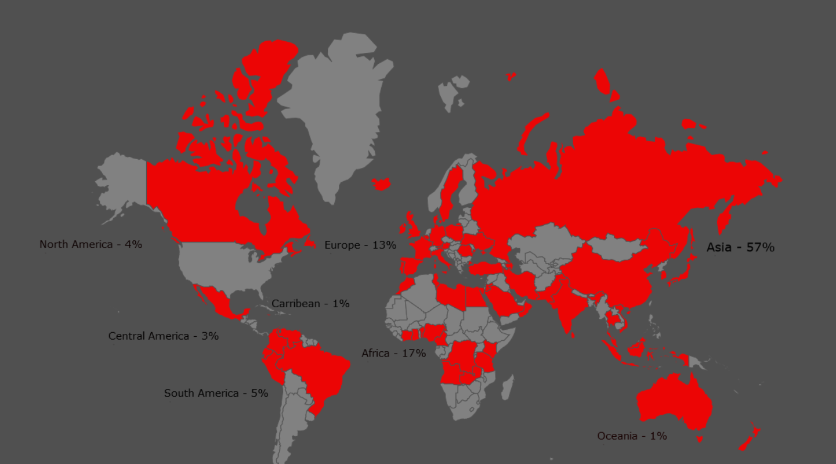
The University of Louisiana at Lafayette enrolls 558 international students and scholars from 69 different countries.

Student Enrollment Top Programs of Study
184 Undergraduates
269 Graduates
49 Exchange & Research Scholars
22 Intensive Language

35 Other visa types

